Guest Portal SSID Configuration: Aruba WLC and Cisco ISE
  - Step-by-step technical documentation

1. Document Control
Document Title | Guest Portal SSID Configuration: Aruba WLC and Cisco ISE
Prepared By | [Alejandro Power / Shipboard Network Operations]
Version | [1.1]
Date | [6/22/2026]
Environment | [GSC]
Change / Request Reference | [CHG0104481]

2. Purpose
This document provides a step-by-step template for configuring a guest portal SSID using Aruba Wireless LAN Controller and Cisco ISE. The intent is to document the configuration workflow, capture screenshots for each step, and provide a repeatable reference for deployment, validation, and troubleshooting.

3. Scope
- Configure Cisco ISE guest portal components.
- Configure Aruba WLC RADIUS integration and captive portal redirection.
- Create or update the guest SSID profile.
- Create firewall rules, interfaces and dns services in the Fortigate
- Validate guest onboarding, portal redirection, authentication, authorization, and internet access.
- Document screenshots for each configuration step.

4. Prerequisites
- Administrative access to Cisco ISE.
- Administrative access to Aruba WLC or Mobility Conductor.
- Guest VLAN created and routable as required.
- DHCP scope configured for the guest VLAN.
- DNS reachability available for guest clients.
- Firewall rules configured for required guest access, Cisco ISE portal access, RADIUS, and CoA.
- Valid certificate installed for the Cisco ISE guest portal to avoid browser trust issues.
- Aruba WLC running a supported ArubaOS version for the required captive portal and RADIUS attributes.

5. Network and Configuration Details
Item | Value | Notes
SSID Name | [NCL_GUEST] | [Guest-WiFi]
Guest VLAN | [66] | [10.142.66.1/23]
Aruba WLC IP Address | [10.142.66.2] | [10.142.0.250]
Cisco ISE PSN | [10.142.0.110-10.142.0.109] | [Portal and RADIUS node details]
RADIUS Shared Secret | [Standard password] | Fleet standard configuration
RADIUS Auth Port | 1812 | N/A
RADIUS Accounting Port | 1813 | N/A
CoA Port | 3799 | [Confirm allowed between ISE and Aruba WLC]
Guest Portal FQDN | [gscguest.nclmiami.com] | [Certificate should match portal FQDN]

6. Cisco ISE Configuration

6.1 Add or Verify Aruba WLC as a Network Device
- Navigate to Administration > Network Resources > Network Devices.
- Select Add or open the existing Aruba WLC device entry.
- Enter the Aruba WLC name, IP address, device type, location, and RADIUS shared secret.
- Enable RADIUS authentication settings.
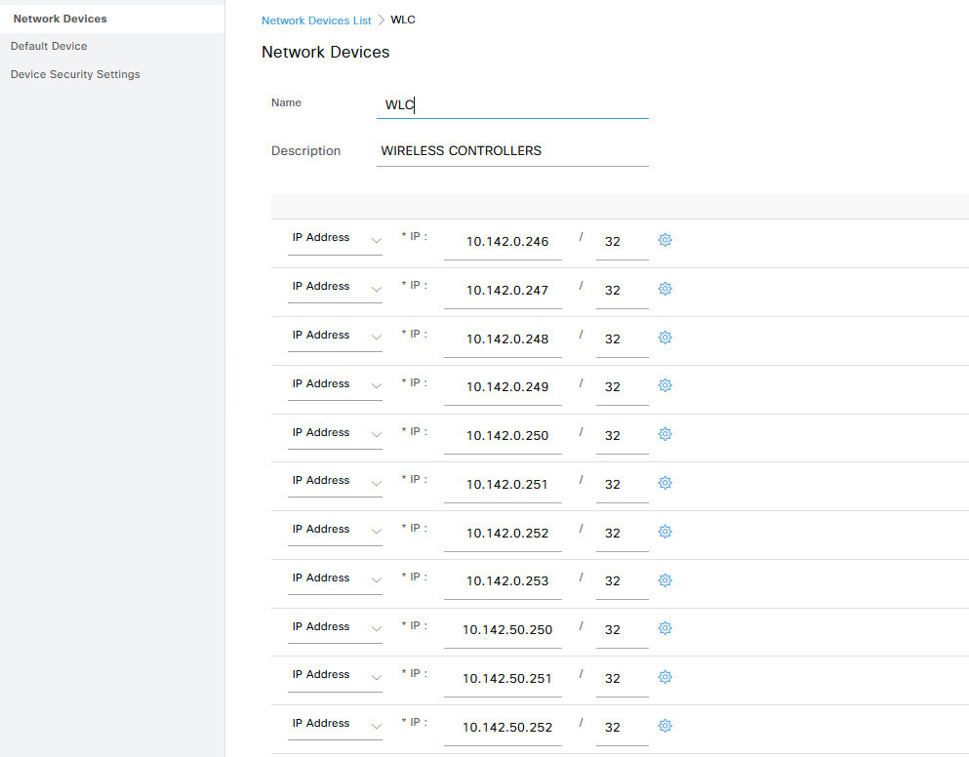
- Assign the Aruba network device profile if required for Aruba-specific attributes and CoA behavior. SUPER IMPORTANT WITHOUT THIS CONFIG THE USERS WONT CHANGE THE ROLE AFTER AUTHENTICATION.
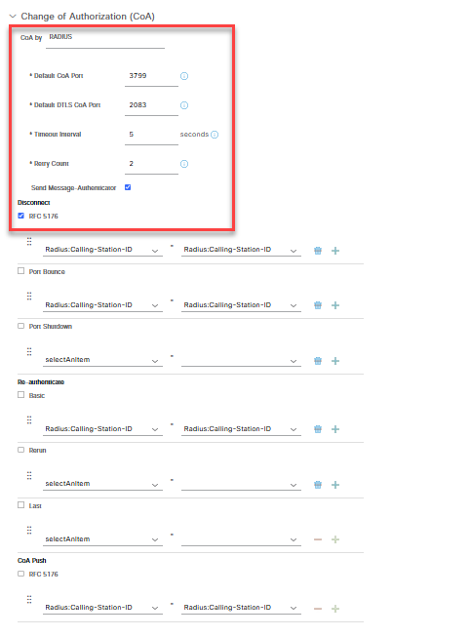
- Save the configuration.

6.2 Configure Guest Portal
- Navigate to Work Centers > Guest Access > Portals & Components > Guest Portals.
- Create or select the required guest portal type, such as Hotspot, Self-Registered Guest, or Sponsored Guest.
- Configure the portal name, HTTPS port, allowed interfaces, certificate, login behavior, AUP settings, and guest user flow.
- Confirm the portal FQDN and certificate are valid and trusted by guest endpoints.
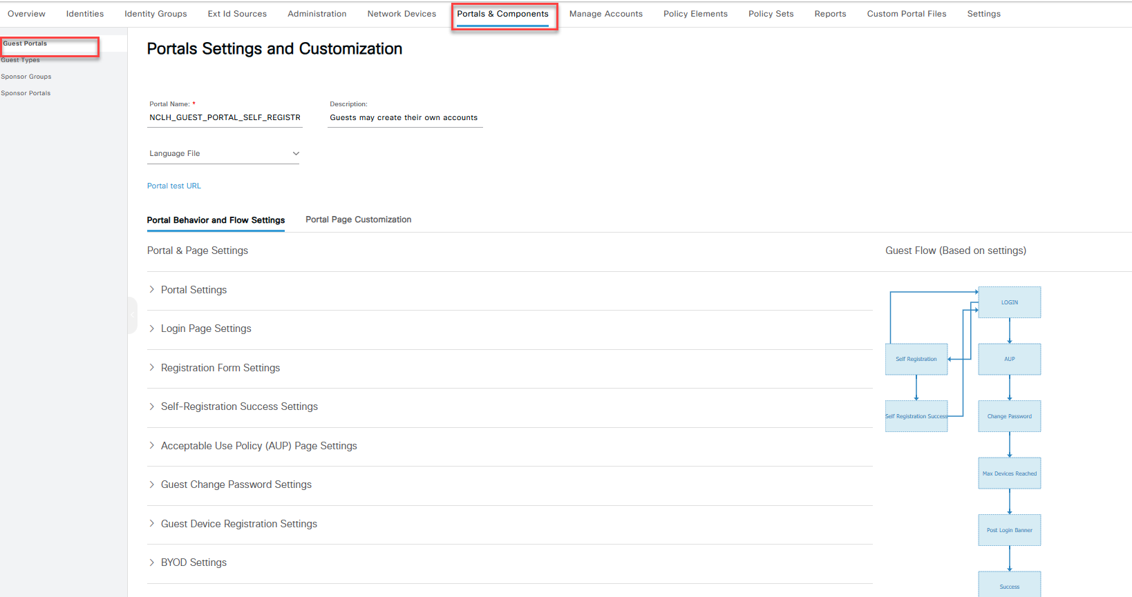
- Save the portal configuration.

6.3 Configure Authorization Profiles
- Navigate to Policy > Policy Elements > Results > Authorization > Authorization Profiles.
- Create a pre-authentication authorization profile for guest redirection.
- Configure the profile to redirect unknown or unauthenticated guest clients to the Cisco ISE guest portal.
- Configure the redirect ACL or Aruba role name expected by the Aruba WLC.
- Create a post-authentication authorization profile for successfully authenticated guest users.
- Assign the final guest VLAN, Aruba user role, or access result as required by the deployment design.
- Save the authorization profiles.
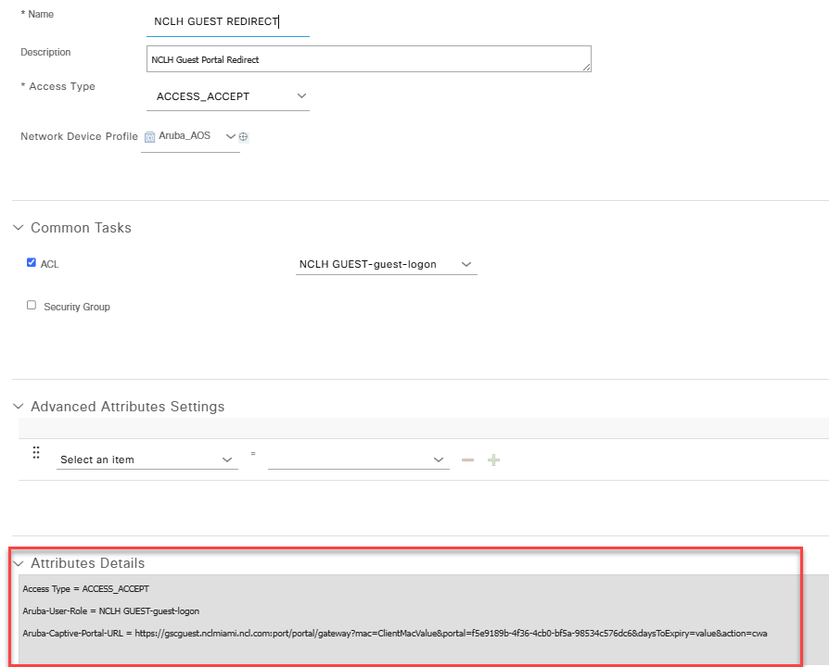
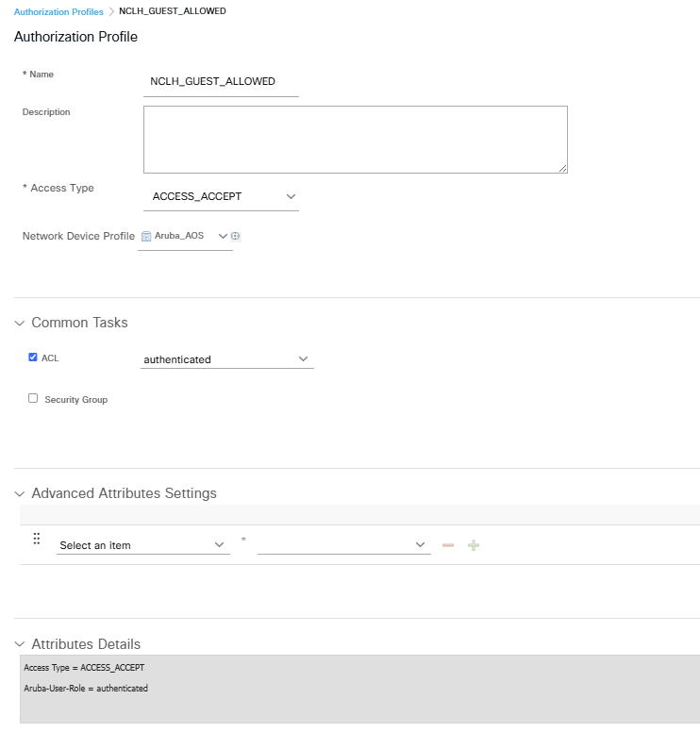

6.4 Configure Policy Set
- Navigate to Policy > Policy Sets.
- Create or update the policy set matching Aruba wireless guest traffic.
- Define the conditions using network device, device type, SSID, NAS-ID, or other available attributes.
- Configure authentication policy for MAB or guest flow as required.
- Configure authorization rules for unknown guest endpoints, guest portal redirection, and completed guest access.
- Save and validate the policy set order.

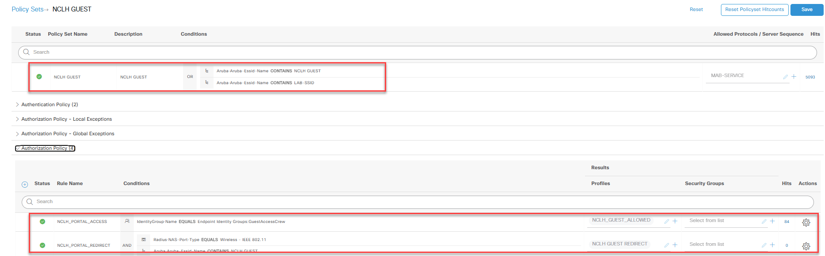7. Aruba WLC Configuration

7.1 Create or Update Guest SSID
- Navigate to the WLAN or SSID configuration section.
- Create a new WLAN or edit the existing guest SSID.
- Set the SSID name and primary usage as Guest.
- Select the AP group or deployment scope where the SSID should be broadcast.
- Assign the guest VLAN or VLAN pool.
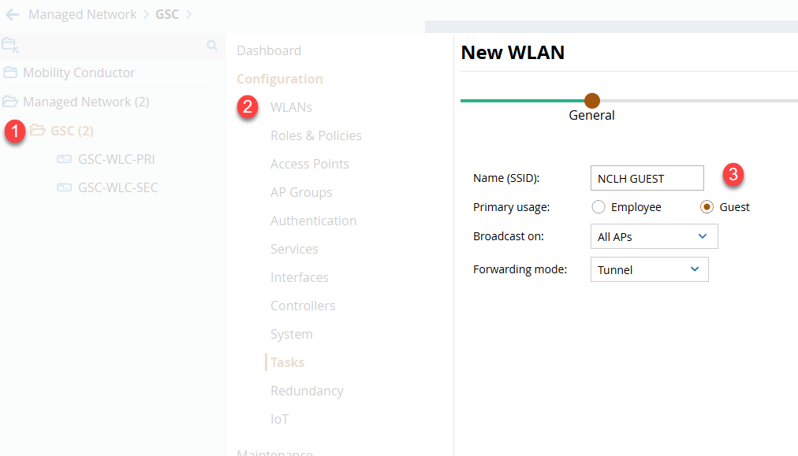
- Configure the forwarding mode based on the deployment design.
- Enable captive portal or internal captive portal as required so Aruba can perform client redirection.
- Assign the Cisco ISE RADIUS server group.
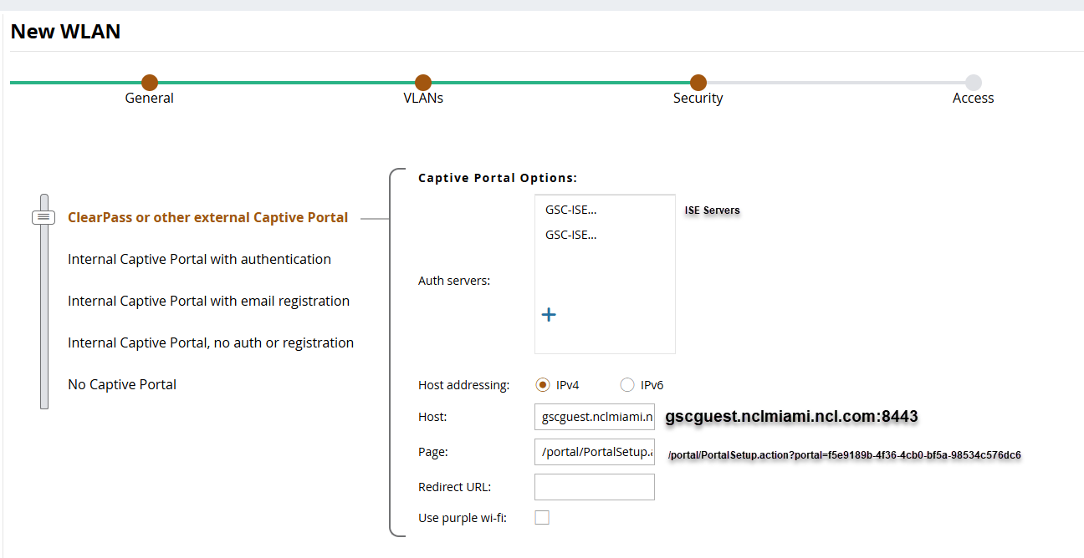
- Assign the pre-authentication role and final guest role as required.
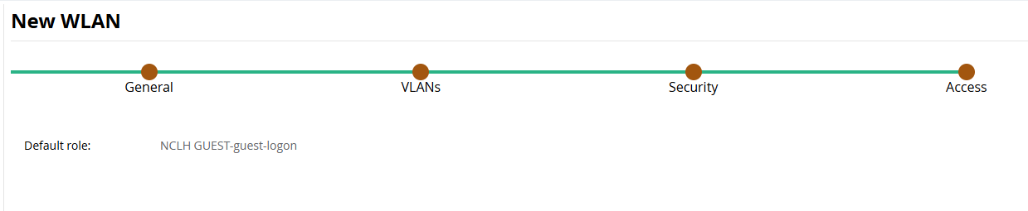
- Save, deploy, and commit pending changes.
- Navigate to Configuration > Authentication > Auth Servers. Click the + button under All Servers. Fill in name, select type as RADIUS, and fill in the IP address/hostname of the ISE PSN. Click Submit. Repeat for each of the ISE PSNs.
- Select the newly created RADIUS Server definition. Enter the Shared Key and click Submit. Repeat for each of the ISE PSN RADIUS Server definitions.
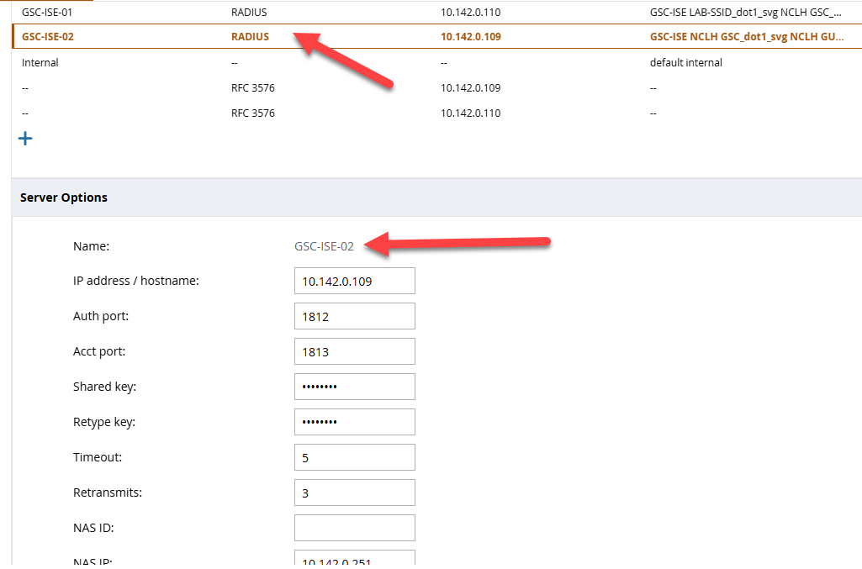
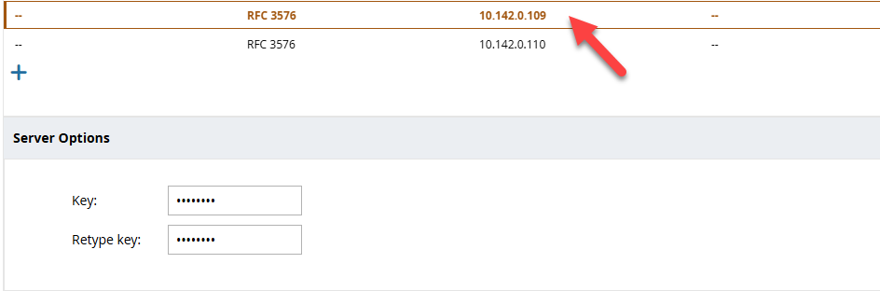
- Navigate to Configuration > Authentication > AAA Profiles. Select the AAA profile for the newly created WLAN, [SSID]_aaa_prof. Enable RADIUS Interim Accounting and DHCP Enforce. Click Submit.
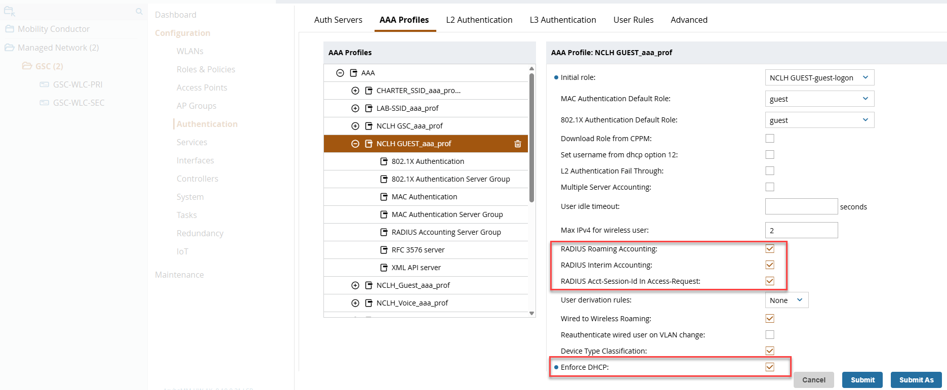
- Select RADIUS Accounting Server Group. Change Server Group to the ISE Server Group created previously. Click Submit.
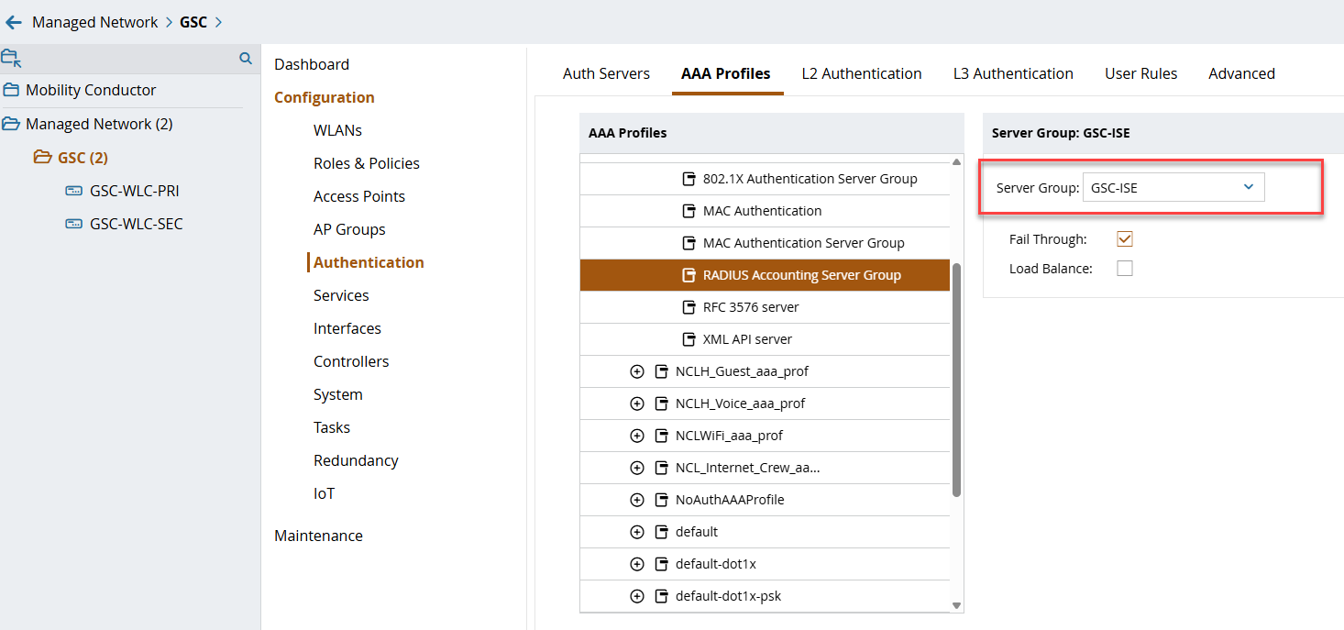
- Select MAC Authentication. Change MAC Authentication Profile to Default. Click Submit.
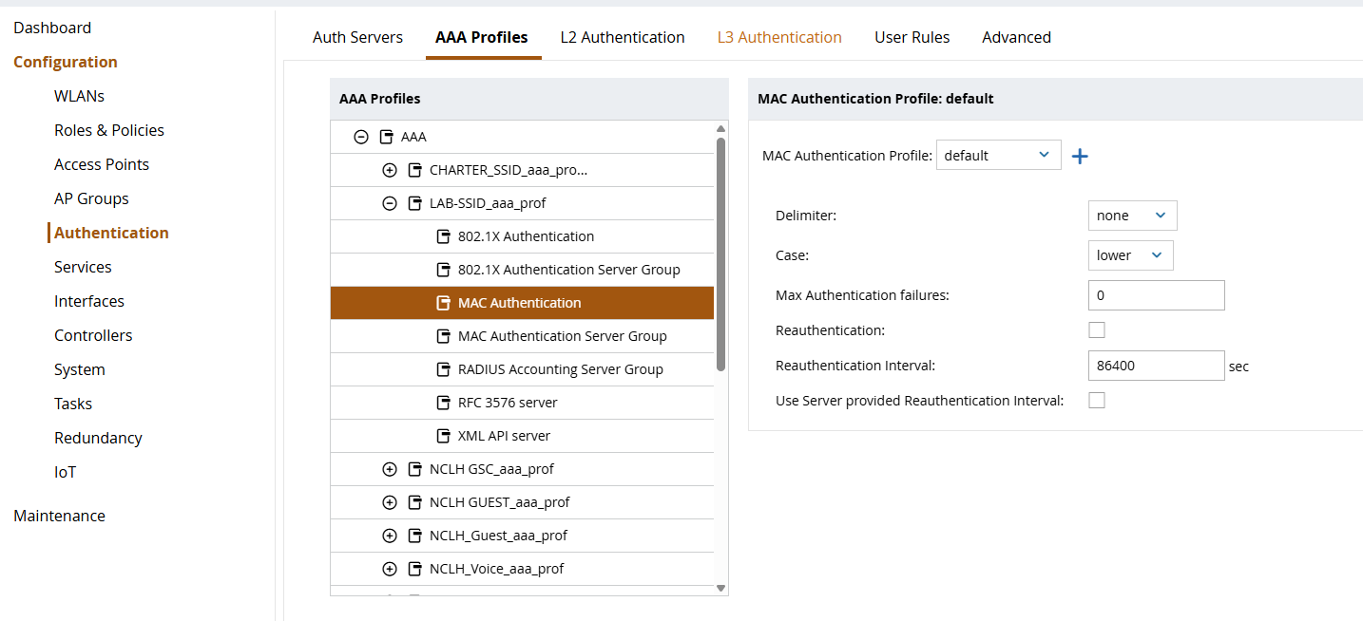

- Select RFC 3576 Server. Click the + button and select the ISE PSN from the drop down. Click Submit. Repeat for each of the ISE PSN RFC 3576 server definitions.
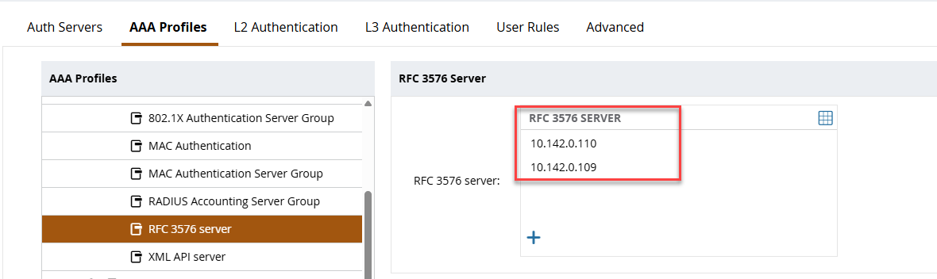
- Click Pending Changes in the top right and click Deploy changes to deploy the configuration to the Mobility Controller.

Role & Policy Configuration
- Navigate to Configuration > Roles & Policies > Policies and click the + button.
- Select the newly created policy and click the + button. Select Access Control and click OK. Create a new forwarding rule allowing captive portal traffic to the ISE PSNs. Click Submit.
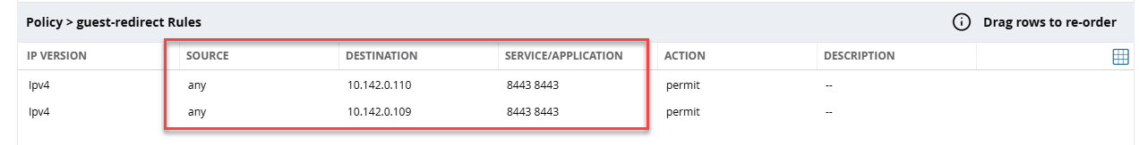
- Select the newly created Role from the list. Click Show Advanced View.
- Click the + button within Policies. Select Add an existing policy. Select type Session and select the policy created in the previous step. Click Submit.
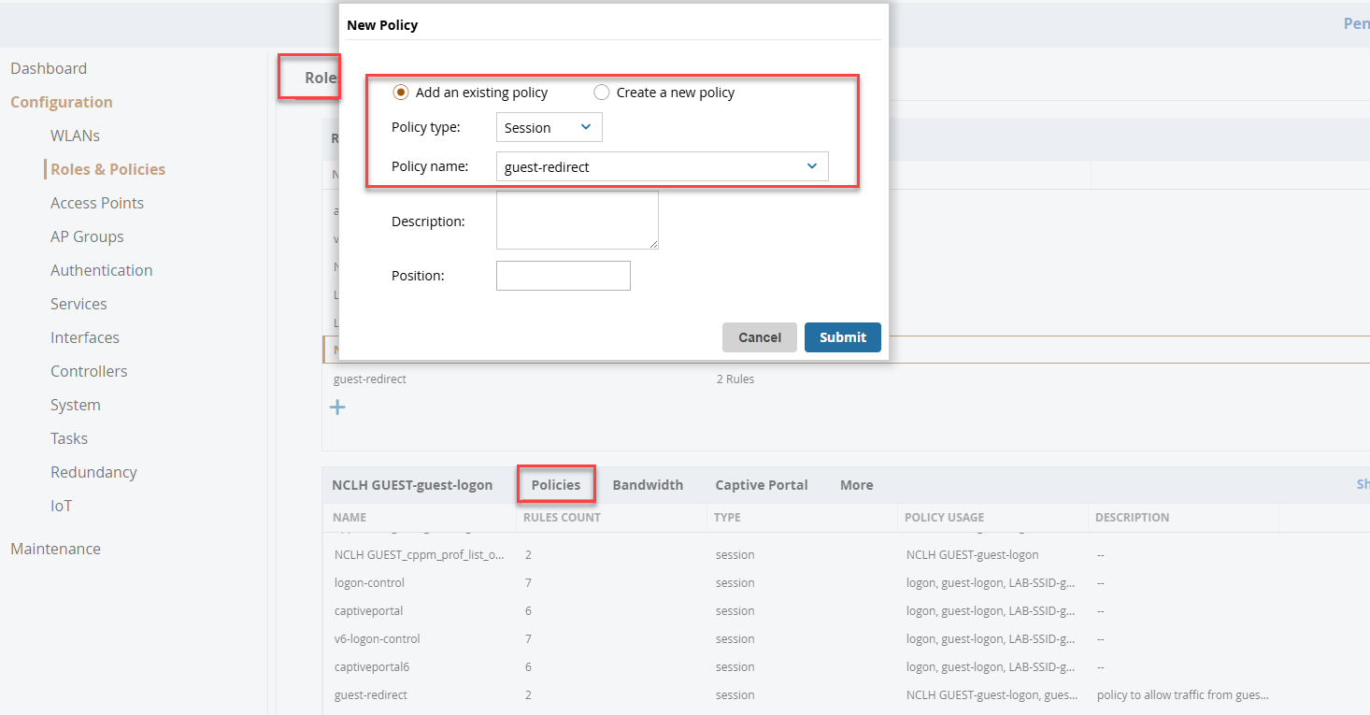
- Select the Captive Portal tab. And make sure configuration is in place.
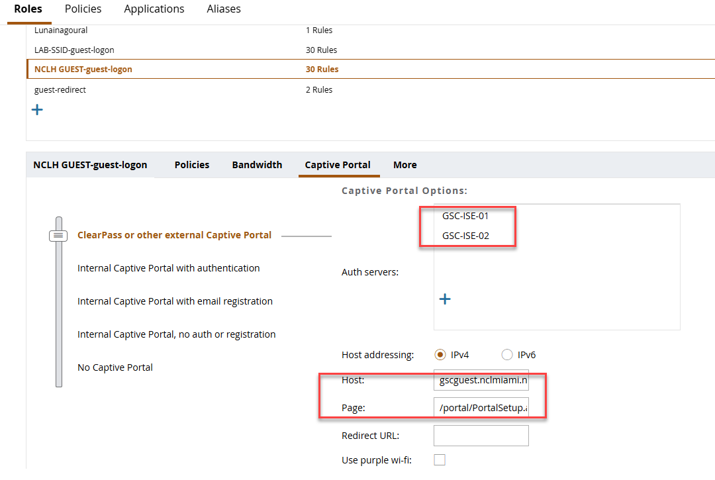
- Click Submit.
- Click Pending Changes in the top right and click Deploy changes to deploy the configuration to the Mobility Controller.
Note: L3 configuration is needed for the guest VLAN in order to work with the guest portal redirection :
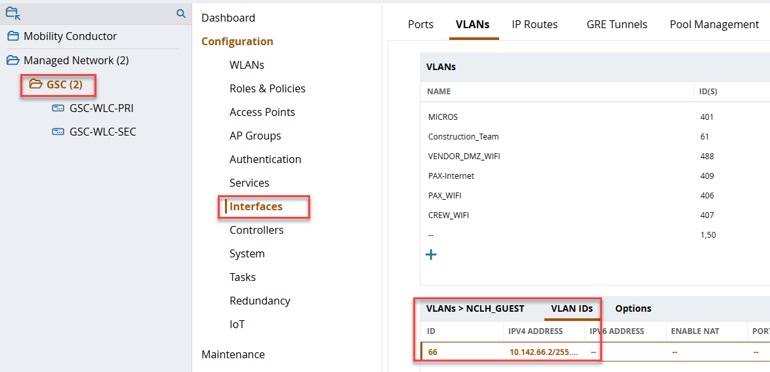

Firewall Configuration
- Configure interface guest VLAN with the firewall as primary dns server.
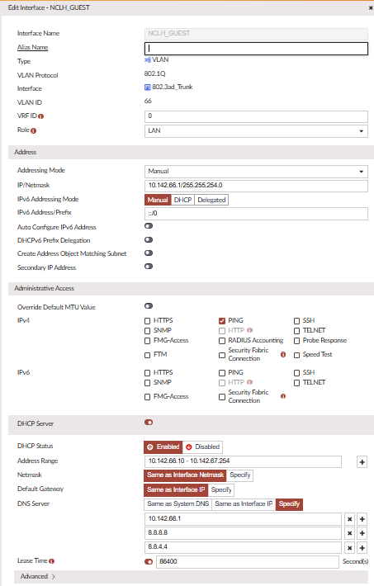
- Navegate to interfaces > DNS Databases
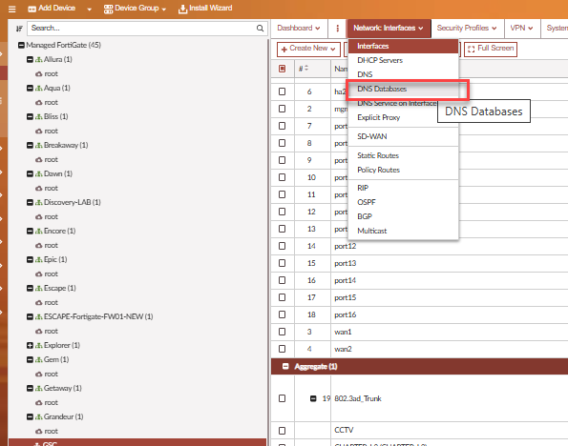
- Create new DNS Database with the A records for guest portal FQDN, sponsor FQDN so the clients can resolve it to the ISE server IP address.
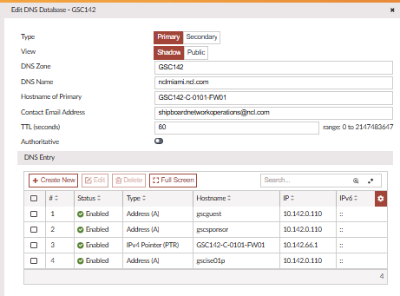
- Create the necessary firewall rules for guest traffic to internal network and internet access.

8. Validation Procedure
- Connect a test client to the guest SSID.
- Confirm the client receives an IP address from the guest VLAN DHCP scope.
- Open a browser and confirm redirection to the Cisco ISE guest portal.
- Complete the guest portal login, registration, or AUP acceptance flow.
- Confirm Cisco ISE sends the expected authorization result and CoA.
- Confirm the client is moved to the final guest role or VLAN.
- Validate DNS resolution and internet access.
- Verify Cisco ISE RADIUS Live Logs show successful authentication and authorization.
- Verify Aruba WLC client details show the expected role, VLAN, IP address, and session state.

10. Troubleshooting Checklist
Issue | Validation | Action
No IP address | Check VLAN, DHCP scope, helper address, and client VLAN assignment. | Correct VLAN or DHCP configuration.
No portal redirect | Check pre-auth role, redirect profile, DNS, portal FQDN, and allowed ACLs. | Allow DNS, DHCP, and ISE portal access; verify redirect authorization profile.
ISE authentication failure | Review Cisco ISE RADIUS Live Logs. | Confirm network device, shared secret, policy set, and endpoint matching conditions.
CoA failure | Check CoA port reachability and Aruba device profile settings. | Allow UDP 3799 and confirm CoA support.
Certificate warning | Check portal certificate CN/SAN and trust chain. | Install or bind a trusted certificate for the guest portal FQDN.
Guest has no internet after login | Check final role, VLAN, firewall policy, NAT, and DNS. | Correct post-auth role and upstream firewall/NAT policy.

12. Implementation Notes
- [GUEST traffic is configured on SD-WAN as local breakout.]
- [Certificate needs to be renewed every 6 months for now]
- [Once users are moved to the new SSID, old SSID with mac authentication will be disabled]

